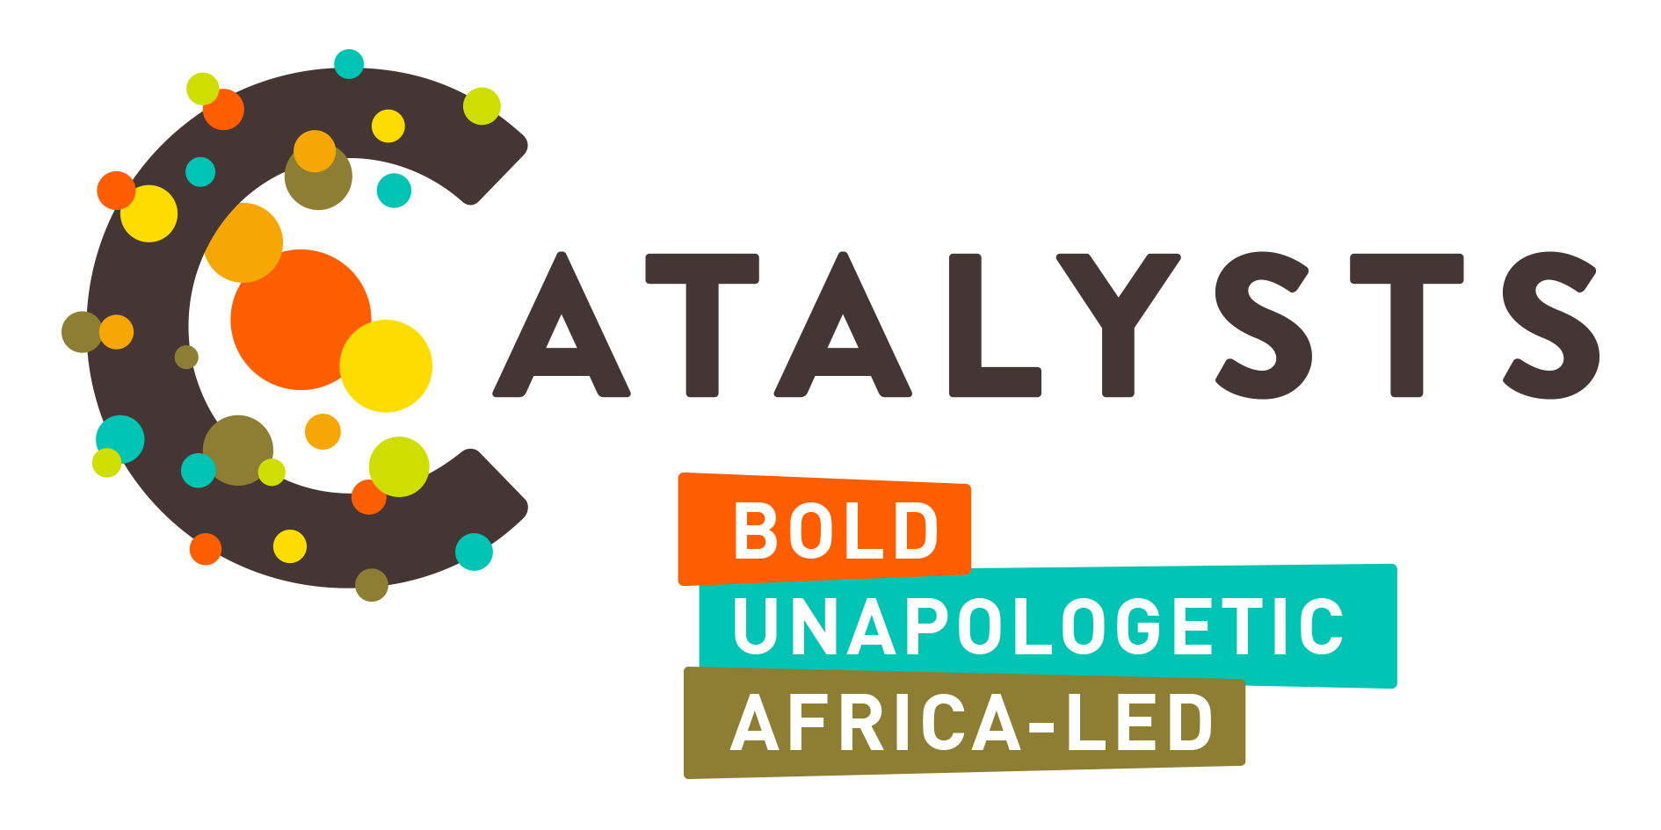

**Call for Expression of Interest (EOI)**

**CATALYTIC FUND – Shifting negative norms and amplifying positive narratives on abortion care and reproductive justice.**

**Application Template**



**1.0 BACKGROUND**

CATALYSTS is a dynamic consortium that emerged organically, driven by a shared vision to strengthen abortion rights across Africa. Initially propelled by five Africa-focused organizations—International Planned Parenthood Federation Africa Regional Office (IPPF-ARO), Ipas Africa Alliance (AA), the Centre for Reproductive Rights (CRR), Population Council-Kenya, and FIGO—the consortium was born out of a collective commitment to safeguarding hard-won gains while steadfastly advocating for the advancement of progressive abortion policies in Africa, with an initial focus in East Africa.

Recognizing the need for broader representation and inclusivity, CATALYSTS has expanded its core group to include locally-led civil society organizations deeply rooted in the region and its realities. This expansion brings valuable grassroots perspectives and expertise from Women’s Global Network for Reproductive Rights-Tanzania (WGNRR), Reach A Hand Uganda (RAHU), and the Women Pro Bono Initiative (WPI). Together, we represent a diverse consortium united in its mission to mobilize collective action, cultivate technical excellence, and amplify positive narratives in support of abortion rights across East Africa.

As the consortium advances its mission to strengthen the abortion rights field, it recognizes that shifting negative social norms and promoting positive narratives are critical to ensuring access to safe abortion care and advancing reproductive justice. Harmful stereotypes and misinformation perpetuate stigma and restrict access, making it essential to embrace innovative and impactful approaches that challenge these barriers and inspire societal change. To this end, we are inviting Expressions of Interest (EOI) from civil society organizations (CSOs) and groups engaged in emerging and innovative initiatives that effectively shift negative norms and amplify positive narratives in support of abortion care and reproductive justice.

Sub-grants will range between US$10,000 and $15,000.



**2.0 WHAT WE ARE LOOKING FOR**

We are particularly interested in catalyzing existing innovative initiatives that demonstrate:

1. Effectiveness: A clear track record or potential to achieve measurable outcomes in shifting social norms and promoting positive narratives around abortion care.

2. Innovation: Novel approaches that creatively address harmful stereotypes and anti-rights narratives. Examples include:

* Leveraging digital platforms or social media for storytelling and advocacy.
* Culturally sensitive approaches that resonate with specific communities.
* Engaging underrepresented groups such as youth, religious leaders, or marginalized communities in dialogue and advocacy.
* Artistic or performative interventions, such as theatre, film, storytelling, or visual arts- should creatively communicate critical themes such as bodily autonomy and reproductive justice while sparking meaningful dialogues around abortion care.

3. Community engagement: Initiatives rooted in the lived experiences of communities, emphasizing participatory approaches that empower individuals to lead change on abortion rights.

4. Scalability and replicability: Projects that offer models or lessons that can be adapted or scaled to other contexts.

5. Intersectionality: A focus on how abortion care intersects with broader issues of gender equality, health equity, and social justice.



1. **ELIGIBILITY**

We encourage submissions from:

* Registered civil society organizations, including grassroots groups and community-based organizations in Kenya, Uganda and Tanzania.
* Emerging groups or collectives that may not be formally registered but can demonstrate accountability mechanisms.
* Grassroots-oriented, with a demonstrated commitment to advancing reproductive justice. Preference will be given to youth-led and women-led organizations or groups rooted in their communities and directly engaging with those most impacted by harmful social norms on abortion rights. Applicants who utilize innovative or promising methodologies to challenge harmful social norms and promote positive narratives. These may include, but are not limited to, community engagement initiatives, storytelling, art and cultural expressions, digital media campaigns, or advocacy efforts led by youth and women or other marginalized groups, with a focus on abortion rights. **4.0 APPLICATION FORM**

|  |  |
| --- | --- |
| **ORGANIZATIONAL PROFILE** | |
| Name of organization/group. |  |
| Location and operational reach. |  |
| Brief description of the organization’s mission, vision, and key achievements, particularly as it relates to abortion rights and access. *(max 250 words)* |  |
| Current annual budget. |  |

**5.0 PROPOSED INITIATIVE**

|  |  |
| --- | --- |
| Title of Initiative |  |
| Description of the innovative approach, including how it addresses harmful norms or promotes positive narratives. *(500 words max)* |  |
| Objectives and expected outcomes. *(250 words max)* |  |
| Target audience and geographical focus. *(250 words max)* |  |

**6.0 IMPLEMENTATION PLAN**

|  |  |
| --- | --- |
| **Key activities and timeline (6-12 months) – ADD ROWS AS NEEDED** | |
| **Activity** | **Timeline** |
|  |  |
|  |  |
|  |  |
|  |  |
|  |  |
|  |  |
|  |  |

**Anticipated challenges and strategies to address them.**

|  |  |
| --- | --- |
| **Anticipated challenges** | **Mitigation Strategies** |
|  |  |
|  |  |
|  |  |
|  |  |

**7.0 BUDGET**

|  |  |
| --- | --- |
| **Budget line items** | **Cost** |
|  |  |
|  |  |
|  |  |
|  |  |
|  |  |

**Budget Narrative (Justification) *250 words max***

**8.0 ADDITIONAL INFORMATION**

|  |  |
| --- | --- |
| How will the initiative’s impact will be measured and documented? *(250 words max)* |  |
| Partnerships or collaborations (if any) *100 words max* |  |
| Examples of previous work (if applicable) *100 words max* |  |